Technical Specifications

Flowchart:

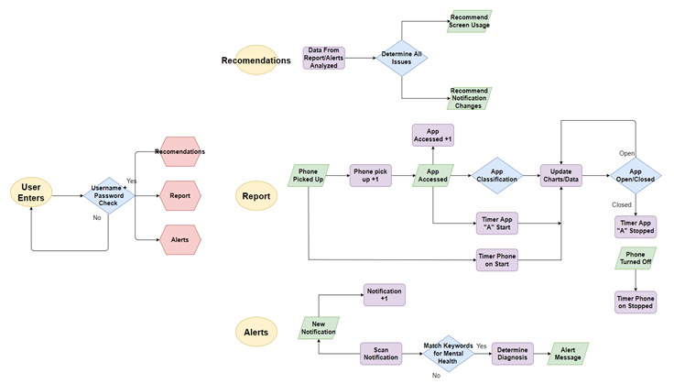

* \*Report Clarification: Timer starts when phone turned on and when app is started. Charts/Data is continually updated till phone is tuned off or app is closed.

UML:

